**Assignment No:-3**

Name:-Suryawanshi Sangramsingh Sambhaji

Batch:-April Date:-30/4/2024

**1. Write a program that takes in an integer and prints all the numbers from 1 to that integer, inclusive.**

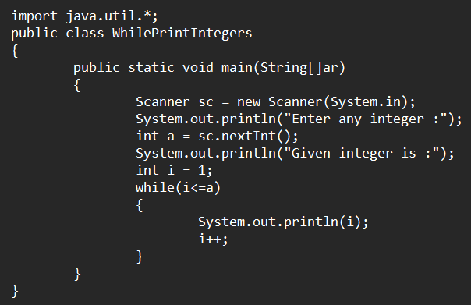

**Output:**

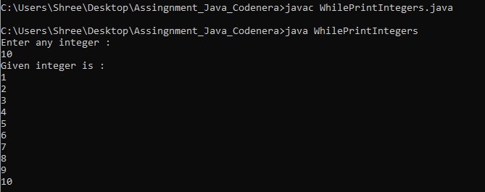

**2. Write a program that takes in an integer and calculate sum of all the numbers from 1 to that integer.**

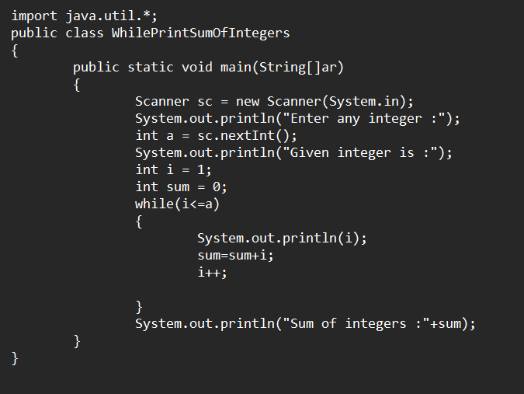

**Output:**

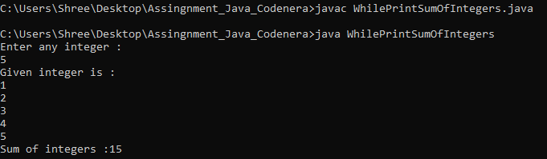

**3. Write a program that takes in an integer and prints all even the numbers from 1 to that integer.**

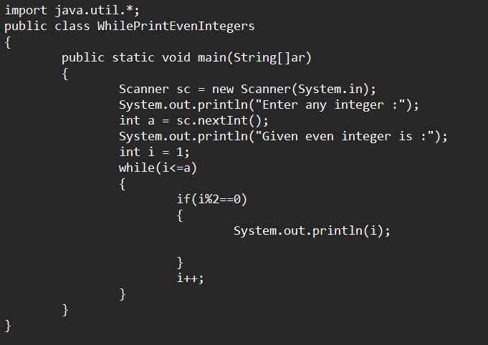**Output:**

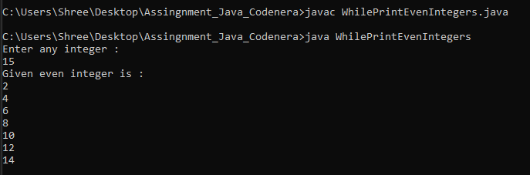

**4. Write a program that takes in an integer and prints all Odd the numbers from 1 to that integer.**

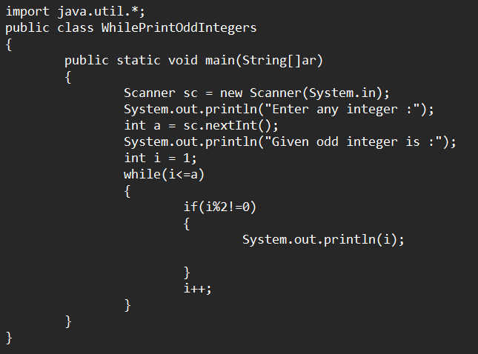**Output:**

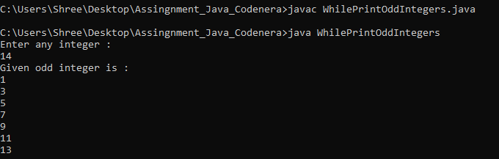

**5. Write a program that takes in an integer and prints sum of all even the numbers from 1 to that integer.**

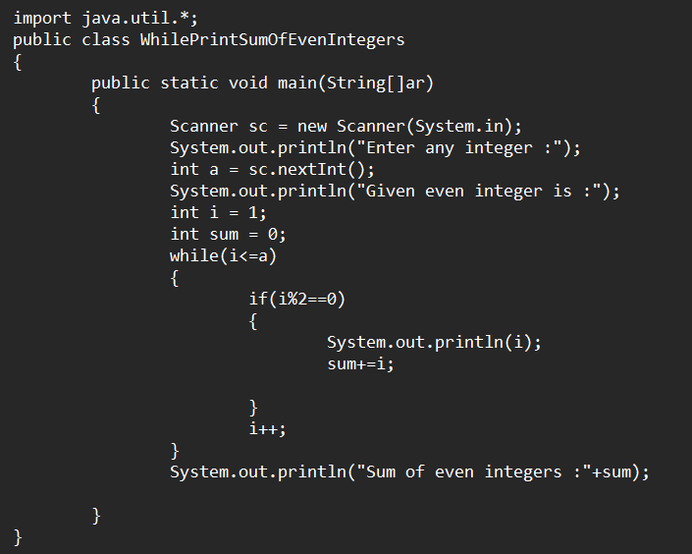**Output:**

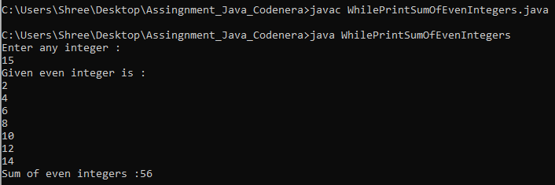

**6. Write a program that takes in an integer and prints sum of all odd the numbers from 1 to that integer.**

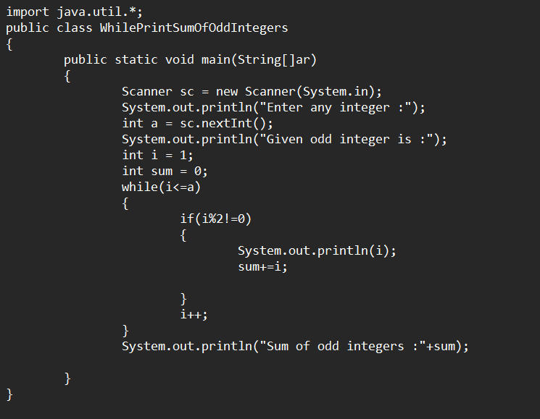**Output:**

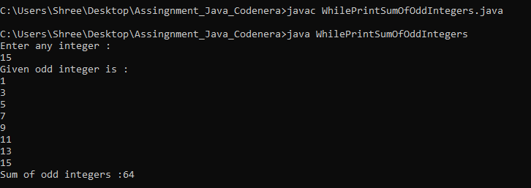

**7. Write a program that takes in an integer and prints count of all even the numbers from 1 to that integer.**

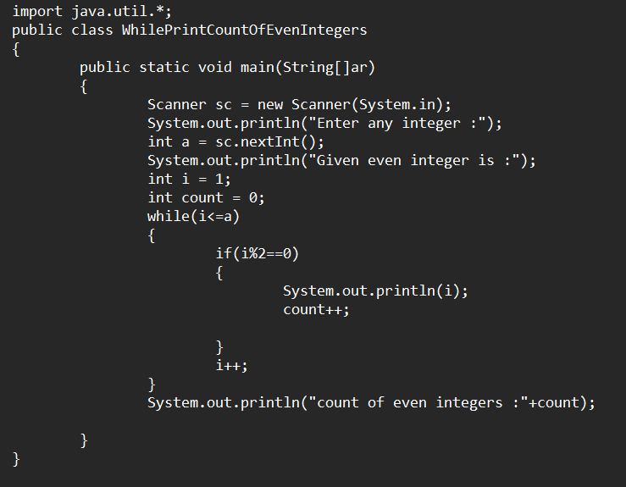**Output:**

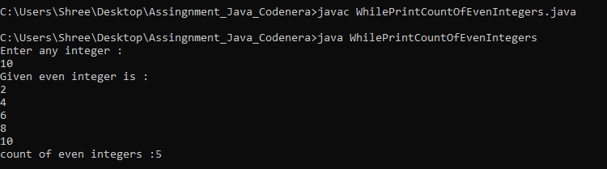

**8. Write a program that takes in an integer and prints count of all odd the numbers from 1 to that integer.**

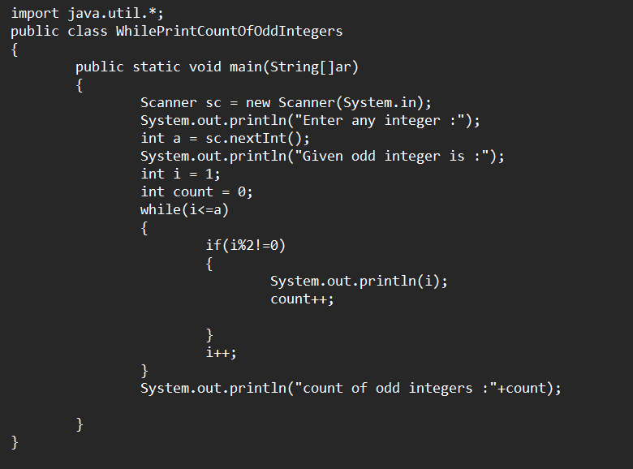**Output:**

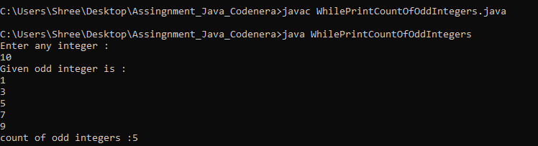

**9. Write a program that takes in an integer and prints count of all even the numbers from 1 to that integer.**

**Output:**



**10. Write a program that takes in an integer and prints count of all odd the numbers from 1 to that integer.**

**Output:**

